What Is Quantitative Research?
Quantitative research is the process of collecting and analyzing numerical data. It can be used to find patterns and averages, make predictions, test causal relationships, and generalize results to wider populations. This is widely used in the natural and social sciences: biology, chemistry, psychology, economics, sociology, marketing, etc.

How to Use Google Forms

You can use Google Forms to create online surveys and quizzes and send them to other people.
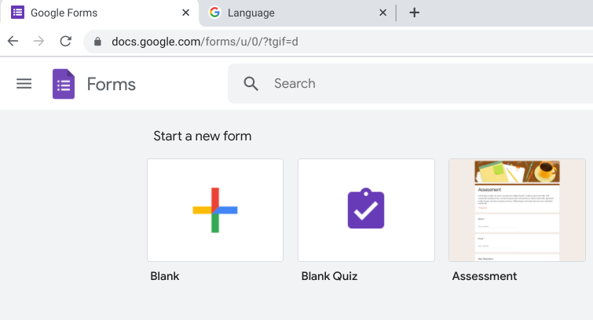
Step 1: Set up a new form or quiz
1.Go to forms.google.com.
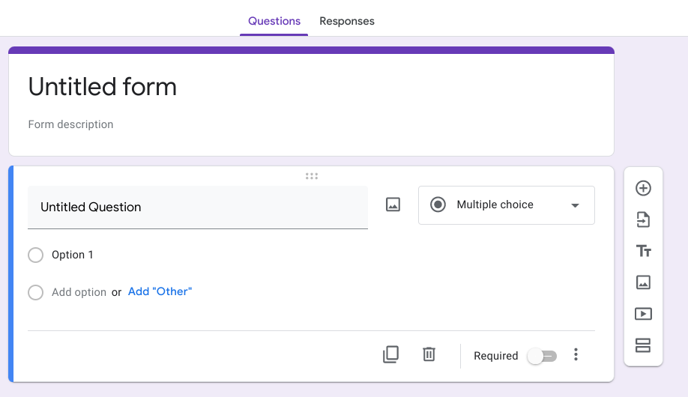
2.Click Blank Plus .
3.A new form will open.

〇Create a form from Google Drive
When you create a Google Form, it’s saved in Google Drive. To create a form directly from Google Drive:
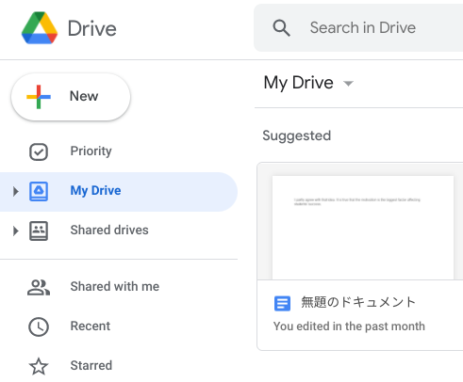
1.On a computer, go to drive.google.com.
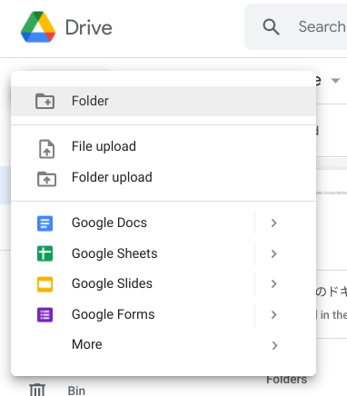
2.In the top left, click New and then Google Forms.

Step 2: Add a question
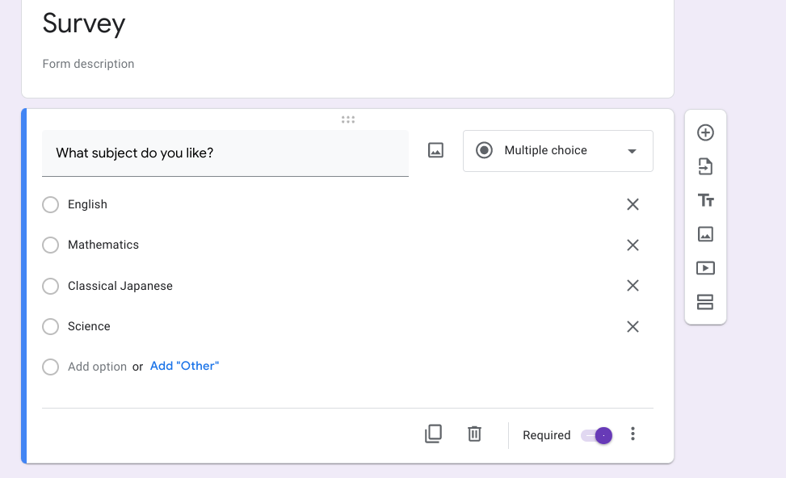
1.In Google Forms, open a form.
2.Click Add .
3.To the right of the question title, choose the type
of question you want.
4.Type the possible responses to your question. To prevent people from not answering, turn on Required.

Step 3: Send your form for people to fill out
When you are ready, you can send your form to others and collect their responses. If you want to share a form through a chat or email message, you can get a link to the form.
1.Open a form in Google Forms.
2.In the top right, click Send.
3.At the top of the window, click Link .
4.To copy the link that appears, click Copy or press Ctrl + c on your keyboard.
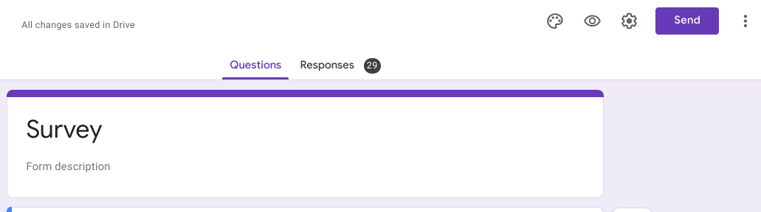
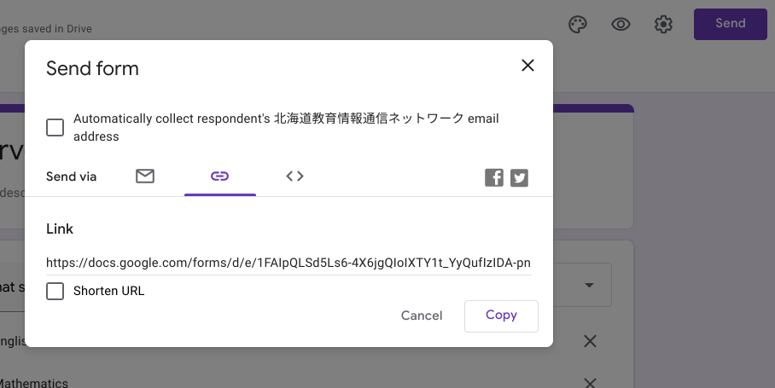

Step 4: View and manage form responses
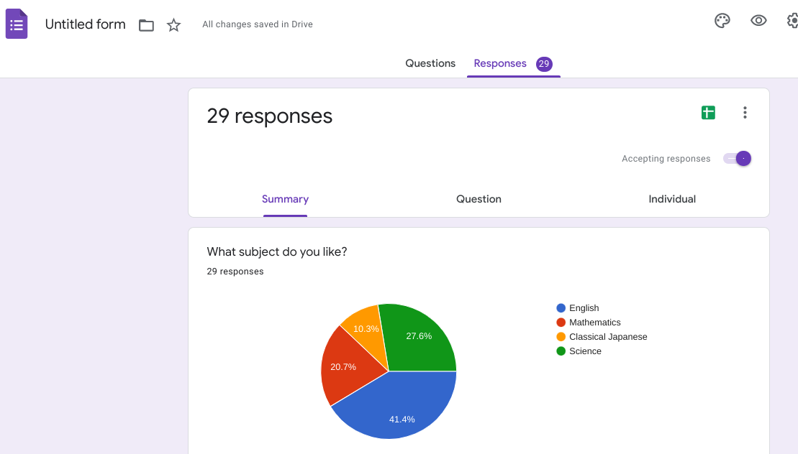
（１）View responses
1.Open a form in Google Forms.
2.At the top of the form, click Responses.
3.Click Summary.
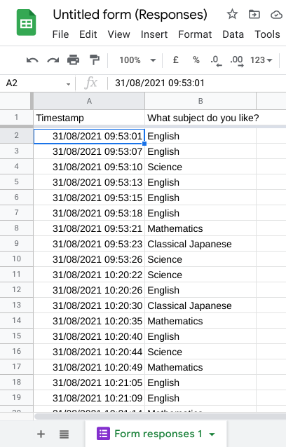
（２）View all responses in a spreadsheet
Easily see all responses in a spreadsheet.
1.Open a form in Google Forms.
2.At the top of the form, click Responses.
3.At the top right, click Create Spreadsheet.

